Paper 3.2

**Questions:**

1. Direct / indirect effects of micro-environmental conditions on seed predation? Indirect effects can occur if temperature and moisture influence individual plant suitability, community context and neighbor/population context, which might in turn have effects on predation.

2. Direct / indirect effects of micro-environmental conditions on plant reproductive success? Indirect effects can occur if temperature and moisture (directly or indirectly 🡪 Question 1) influence seed predation, which affects plant reproductive success.

**Main results:** Micro-environmental conditions affect predation both directly and indirectly (temperature and moisture show interacting effects on plant phenology, ants and neighborhood suitability). Micro-environmental conditions affect plant fitness only indirectly, through their (direct and indirect) effects on seed predation.

**Title:** Something like… Multiple-level (direct and indirect) effects of micro-environmental conditions on plant reproductive success in presence of an antagonist

**Main differences with previous papers:** We consider reproductive success as number of seeds per flower, we assess the effects of both temperature and moisture, large sample sizes…

Effects of micro-environmental conditions on plant reproductive success

Plants produced less seeds per flower at higher temperatures, and moisture had no effect. There was no interactive effect of temperature and moisture.

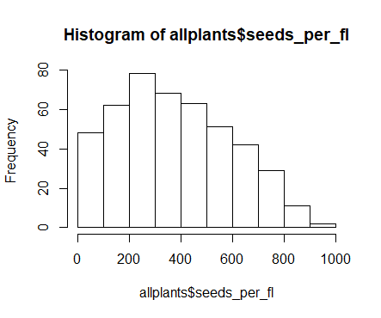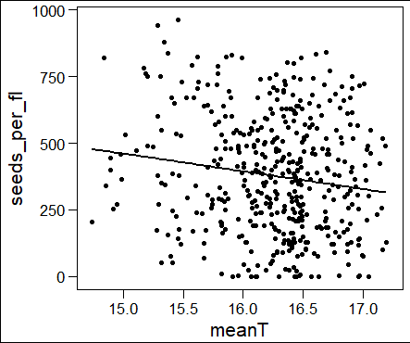

Coefficients (linear model):

Estimate Std. Error t value Pr(>|t|)

(Intercept) 1456.99 341.59 4.265 2.43e-05 ***

meanT -66.41 21.00 -3.162 0.00167 **

Multiple R-squared: 0.02164, Adjusted R-squared: 0.01947,

F-statistic: 9.996 on 1 and 452 DF, p-value: 0.001674, nobs=454

Effects of micro-environmental conditions on plant reproductive success could be complex, as temperature and moisture could affect fruit and/or seed production directly, but also indirectly through effects at multiple levels:

* What we could call “first-level” indirect effects:
  + temperature and moisture 🡪 seed predation by *P. alcon* 🡪 plant reproductive success
* … and what we could call “second-level” indirect effects:
  + temperature and moisture 🡪 plant suitability (i.e. phenology)
  + temperature and moisture 🡪 community context (i.e. ant abundance)
  + temperature and moisture 🡪 neighborhood/population context (i.e. neighbor suitability = density x phenology of the neighboring conspecific plants)

… because pl. suitability + comm. context + pop. context 🡪 predation 🡪 repr. success

Direct effects of micro-environmental conditions on pl repr success (n seeds per fl) 🡪 NO

With attack, only effect of predation!

Coefficients (linear model, n = 454):

Estimate Std. Error t value Pr(>|t|)

(Intercept) 830.4017 424.7221 1.955 0.0512 .

phen_int 14.7703 9.6034 1.538 0.1247

meanT -26.3908 23.9103 -1.104 0.2703

moist_per -0.4627 0.9050 -0.511 0.6094

attack_f1 -197.7449 20.6922 -9.556 <2e-16 ***

Multiple R-squared: 0.1883, Adjusted R-squared: 0.1811

F-statistic: 26.04 on 4 and 449 DF, p-value: < 2.2e-16

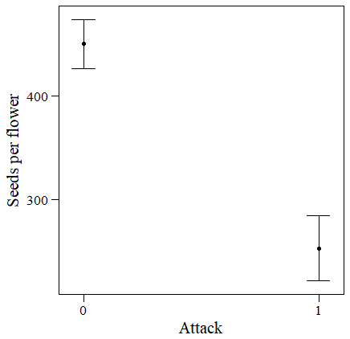

With n eggs, only effects of phenology and predation!

Coefficients (negative binomial GLM, n = 168):

Estimate Std. Error t value Pr(>|t|)

(Intercept) -321.807 597.361 -0.539 0.59082

phen_int 45.260 16.306 2.776 0.00615 **

meanT 18.785 33.246 0.565 0.57284

moist_per 1.375 1.280 1.075 0.28401

n_eggs_max -8.705 2.136 -4.076 7.14e-05 ***

Multiple R-squared: 0.1209, Adjusted R-squared: 0.09938

F-statistic: 5.607 on 4 and 163 DF, p-value: 0.0002971

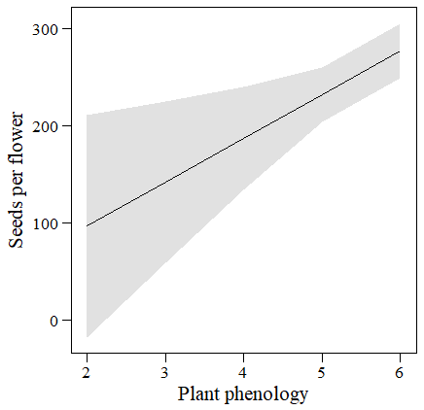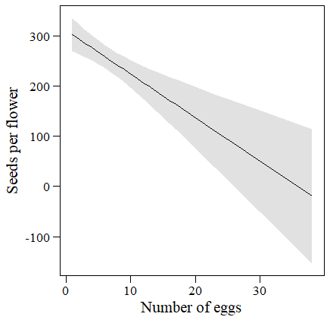

“First-level” indirect effects:

environmental conditions 🡪 attack

Coefficients (binomial GLM, n = 8848):

Estimate Std. Error z value Pr(>|z|)

(Intercept) -31.752836 2.263202 -14.030 < 2e-16 ***

phen_int 0.815526 0.052724 15.468 < 2e-16 ***

Mrub_sch_s -0.137267 0.074492 -1.843 0.0654 .

suit_neigh -0.045970 0.002177 -21.117 < 2e-16 ***

meanT 1.522937 0.125877 12.099 < 2e-16 ***

moist_per 0.042798 0.005372 7.967 1.63e-15 ***

phen_int:Mrub_sch_s 0.037054 0.014883 2.490 0.0128 *

Null deviance: 5045.4 on 8847 degrees of freedom

Residual deviance: 3141.0 on 8841 degrees of freedom

(4 observations deleted due to missingness)

AIC: 3155

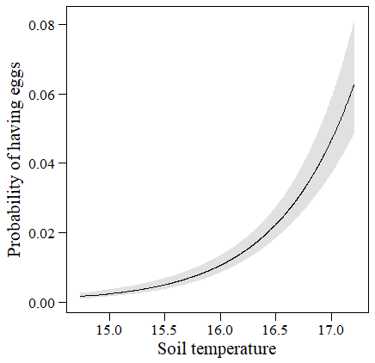 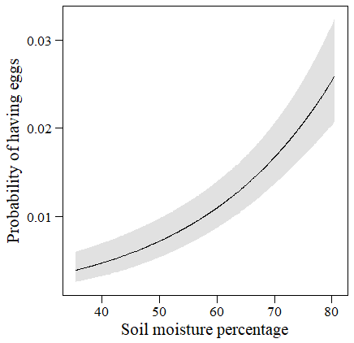

environmental conditions 🡪 n eggs

Coefficients (negative binomial GLM, n = 731):

(interactions phen x ants and temp x moist were NS)

Estimate Std. Error z value Pr(>|z|)

(Intercept) -6.717972 1.643522 -4.088 4.36e-05 ***

phen_int 0.295240 0.039686 7.439 1.01e-13 ***

Mrub_sch_s 0.021861 0.007875 2.776 0.0055 **

suit_neigh -0.012596 0.001758 -7.164 7.82e-13 ***

meanT 0.367808 0.090430 4.067 4.76e-05 ***

moist_per 0.015615 0.003922 3.982 6.84e-05 ***

Null deviance: 845.54 on 730 degrees of freedom

Residual deviance: 711.66 on 725 degrees of freedom

AIC: 3782.3

2 x log-likelihood: -3768.273

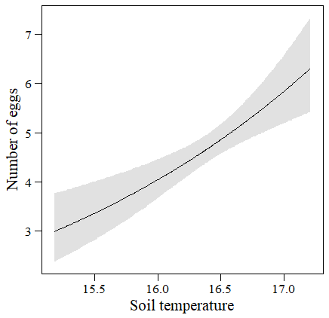 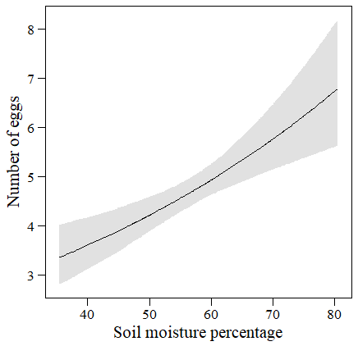

“Second-level” indirect effects:

temperature and moisture 🡪 plant suitability (i.e. phenology)

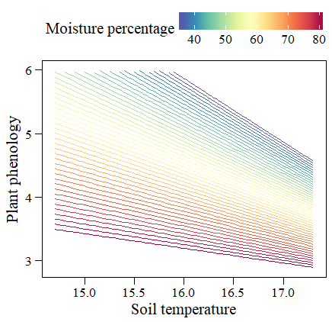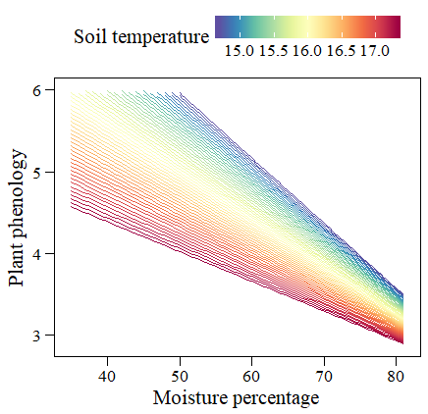

Coefficients (linear model, n=8848):

Estimate Std. Error t value Pr(>|t|)

(Intercept) 33.235799 4.132677 8.042 9.96e-16 ***

meanT -1.583246 0.252060 -6.281 3.52e-10 ***

moist_per -0.325415 0.058172 -5.594 2.28e-08 ***

meanT:moist_per 0.016701 0.003555 4.697 2.68e-06 ***

Multiple R-squared: 0.1151, Adjusted R-squared: 0.1148

F-statistic: 383.4 on 3 and 8844 DF, p-value: < 2.2e-16

temperature and moisture 🡪 community context (i.e. ant abundance)

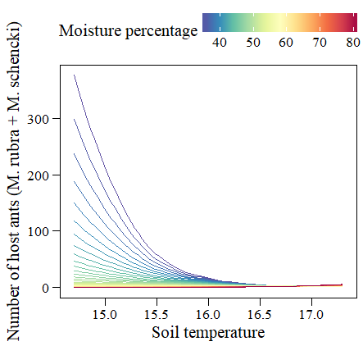 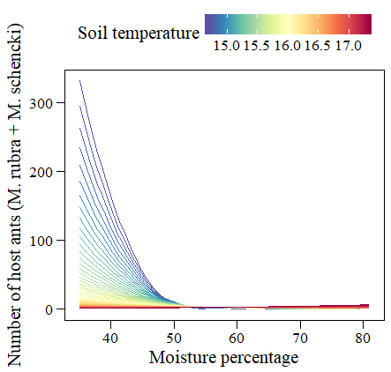

Coefficients (negative binomial, n=8852):

Estimate Std. Error z value Pr(>|z|)

(Intercept) 106.667893 5.334026 20.00 <2e-16 ***

meanT -6.279957 0.324828 -19.33 <2e-16 ***

moist_per -1.843120 0.079656 -23.14 <2e-16 ***

meanT:moist_per 0.109183 0.004855 22.49 <2e-16 ***

Null deviance: 9334.3 on 8851 degrees of freedom

Residual deviance: 7384.0 on 8848 degrees of freedom

temperature and moisture 🡪 neighborhood/population context (i.e. neighbor suitability = density x phenology of the neighboring conspecific plants)

Neighbor density

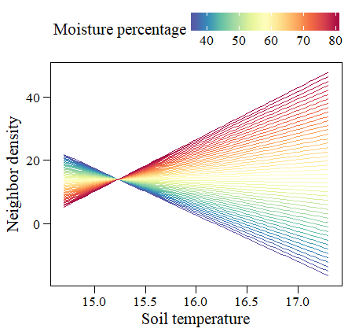 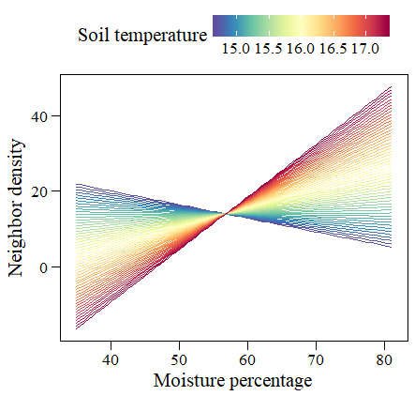

Coefficients (linear model, n=8852):

Estimate Std. Error t value Pr(>|t|)

(Intercept) 598.61363 24.05240 24.89 <2e-16 ***

meanT -38.36764 1.46703 -26.15 <2e-16 ***

moist_per -10.29290 0.33858 -30.40 <2e-16 ***

meanT:moist_per 0.67556 0.02069 32.64 <2e-16 ***

Multiple R-squared: 0.4801, Adjusted R-squared: 0.48

F-statistic: 2724 on 3 and 8848 DF, p-value: < 2.2e-16

Neighbor phenology

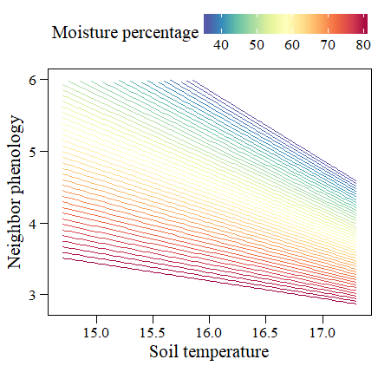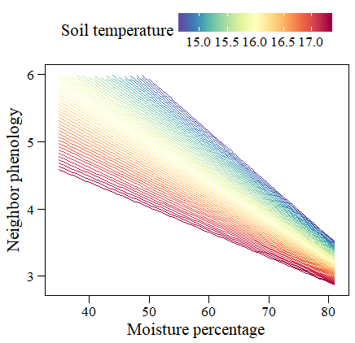

Coefficients (linear model, n=8852):

Estimate Std. Error t value Pr(>|t|)

(Intercept) 32.2220710 1.0109290 31.87 <2e-16 ***

meanT -1.5220120 0.0616598 -24.68 <2e-16 ***

moist_per -0.3097848 0.0142306 -21.77 <2e-16 ***

meanT:moist_per 0.0157516 0.0008698 18.11 <2e-16 ***

Multiple R-squared: 0.6834, Adjusted R-squared: 0.6833

F-statistic: 6368 on 3 and 8848 DF, p-value: < 2.2e-16

Neighbor suitability (=density x phenology)

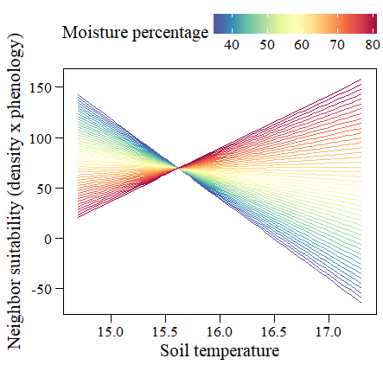 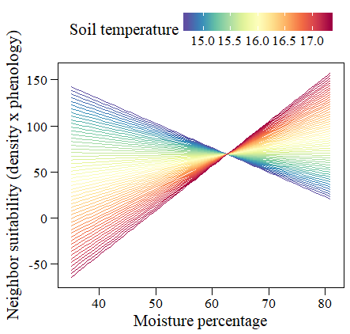

Coefficients (linear model, n=8852):

Estimate Std. Error t value Pr(>|t|)

(Intercept) 2886.1527 90.5416 31.88 <2e-16 ***

meanT -180.3224 5.5224 -32.65 <2e-16 ***

moist_per -44.9463 1.2745 -35.27 <2e-16 ***

meanT:moist_per 2.8771 0.0779 36.93 <2e-16 ***

Multiple R-squared: 0.3703, Adjusted R-squared: 0.3701

F-statistic: 1734 on 3 and 8848 DF, p-value: < 2.2e-16

AND

pl. suitability * comm. context + pop. context 🡪 attack

Coefficients (binomial GLM, n = 8848):

Estimate Std. Error z value Pr(>|z|)

(Intercept) -31.752836 2.263202 -14.030 < 2e-16 ***

phen_int 0.815526 0.052724 15.468 < 2e-16 ***

Mrub_sch_s -0.137267 0.074492 -1.843 0.0654 .

suit_neigh -0.045970 0.002177 -21.117 < 2e-16 ***

meanT 1.522937 0.125877 12.099 < 2e-16 ***

moist_per 0.042798 0.005372 7.967 1.63e-15 ***

phen_int:Mrub_sch_s 0.037054 0.014883 2.490 0.0128 *

Null deviance: 5045.4 on 8847 degrees of freedom

Residual deviance: 3141.0 on 8841 degrees of freedom

(4 observations deleted due to missingness)

AIC: 3155

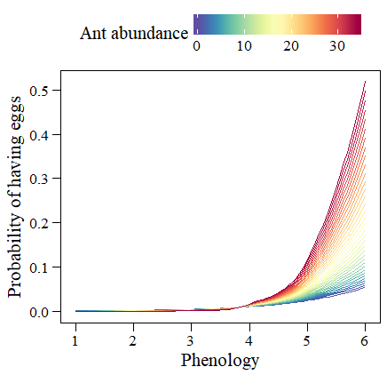 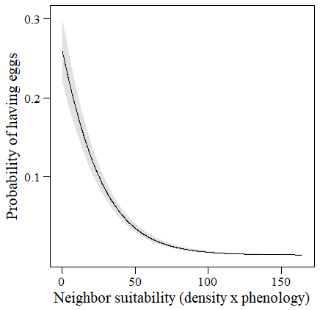

pl. suitability + comm. context + pop. context 🡪 n eggs

Coefficients (negative binomial GLM, n = 731):

(interactions phen x ants and temp x moist were NS)

Estimate Std. Error z value Pr(>|z|)

(Intercept) -6.717972 1.643522 -4.088 4.36e-05 ***

phen_int 0.295240 0.039686 7.439 1.01e-13 ***

Mrub_sch_s 0.021861 0.007875 2.776 0.0055 **

suit_neigh -0.012596 0.001758 -7.164 7.82e-13 ***

meanT 0.367808 0.090430 4.067 4.76e-05 ***

moist_per 0.015615 0.003922 3.982 6.84e-05 ***

Null deviance: 845.54 on 730 degrees of freedom

Residual deviance: 711.66 on 725 degrees of freedom

AIC: 3782.3

2 x log-likelihood: -3768.273

